**PRACTICAL NO: 5**

**AIM: IMPLEMENTING THE CONCEPT OF INTEGRITY CONSTRAINTS**

**USE FYIT_40**

**PRIMARY CONSTRAINTS**

CREATE TABLE CLIENT

(CLIENT_NO VARCHAR(5)CONSTRAINT PKCLIENT PRIMARY KEY(CLIENT_NO),

CNAME VARCHAR(10),

CITY VARCHAR(10))

SELECT * FROM CLIENT

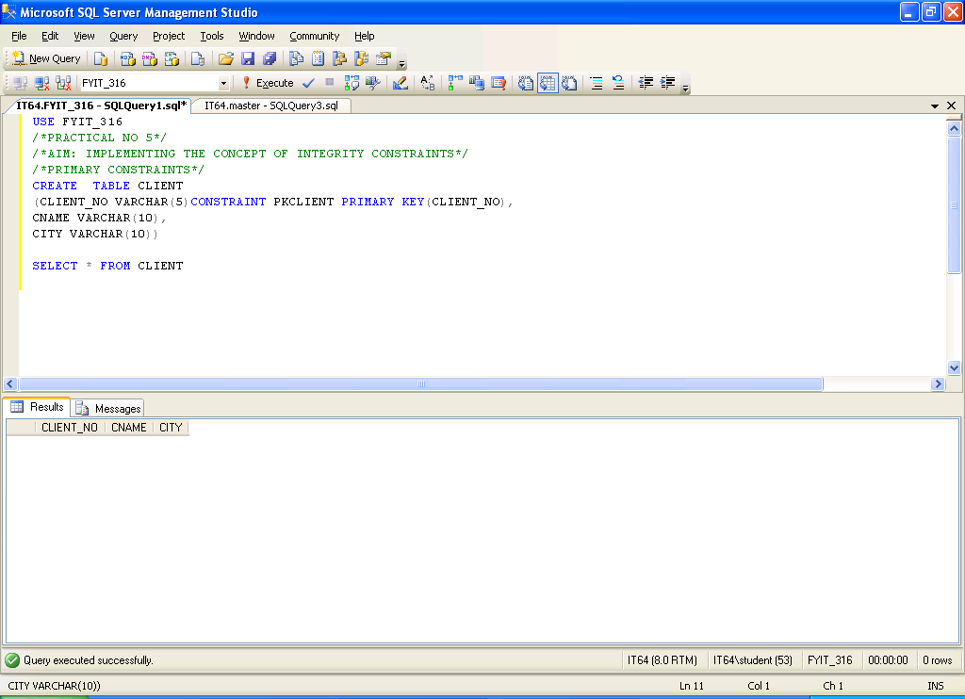

**FOREIGN KEY CONSTRAINTS**

CREATE TABLE ACCOUNTS

(ACC_NO VARCHAR(5)CONSTRAINT PKACC PRIMARY KEY(ACC_NO),

ACC_TYPE VARCHAR(10),

CLIENT_NO VARCHAR(5)CONSTRAINT FKCLIENT FOREIGN KEY(CLIENT_NO)REFERENCES CLIENT)

SELECT * FROM ACCOUNTS

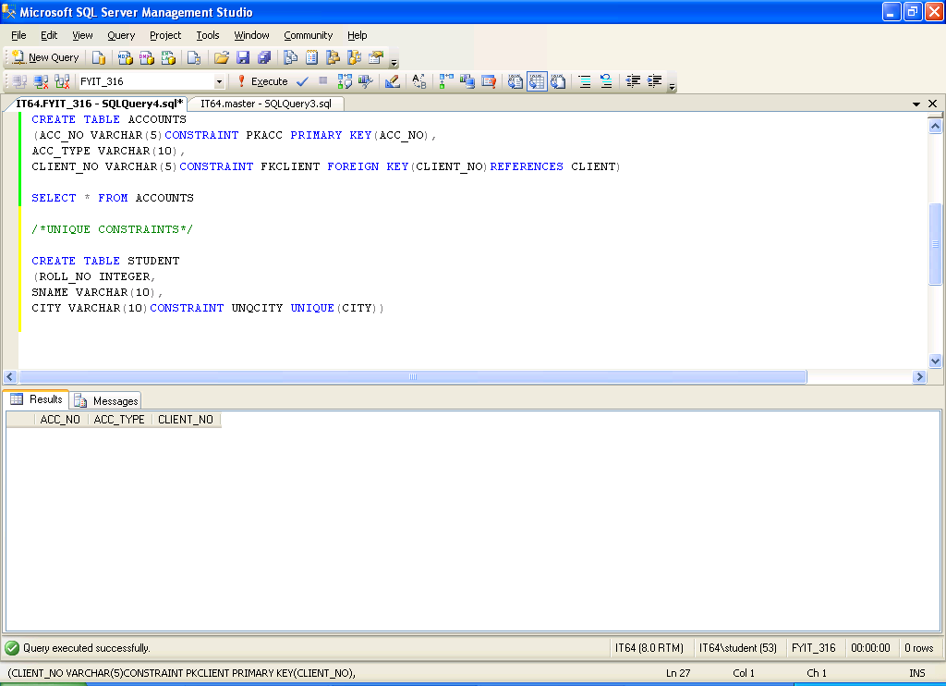

**UNIQUE CONSTRAINTS**

CREATE TABLE STUD

(ROLL_NO INTEGER,

SNAME VARCHAR(10),

CITY VARCHAR(10)UNIQUE)

SELECT * FROM STUD

CREATE TABLE STUDENT

(ROLL_NO INTEGER,

SNAME VARCHAR(10),

CITY VARCHAR(10)CONSTRAINT UNQCITY UNIQUE(CITY))

SELECT * FROM STUDENT

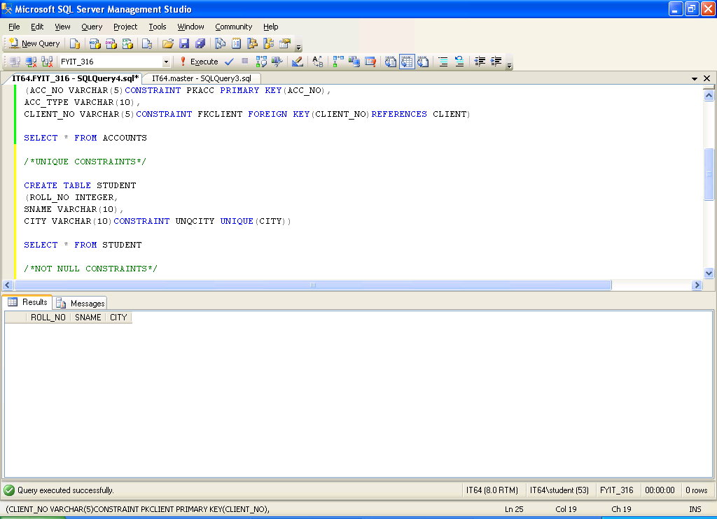

**CHECK CONSTRAINTS**

CREATE TABLE SALESPERSON

(SNO INTEGER,

SNAME VARCHAR(15),

AGE INTEGER CHECK(AGE>18))

SELECT * FROM SALESPERSON

CREATE TABLE SALESMAN

(SNO INTEGER,

SNAME VARCHAR(15),

AGE INTEGER CONSTRAINT CHKAGE CHECK(AGE>18))

SELECT * FROM SALESMAN

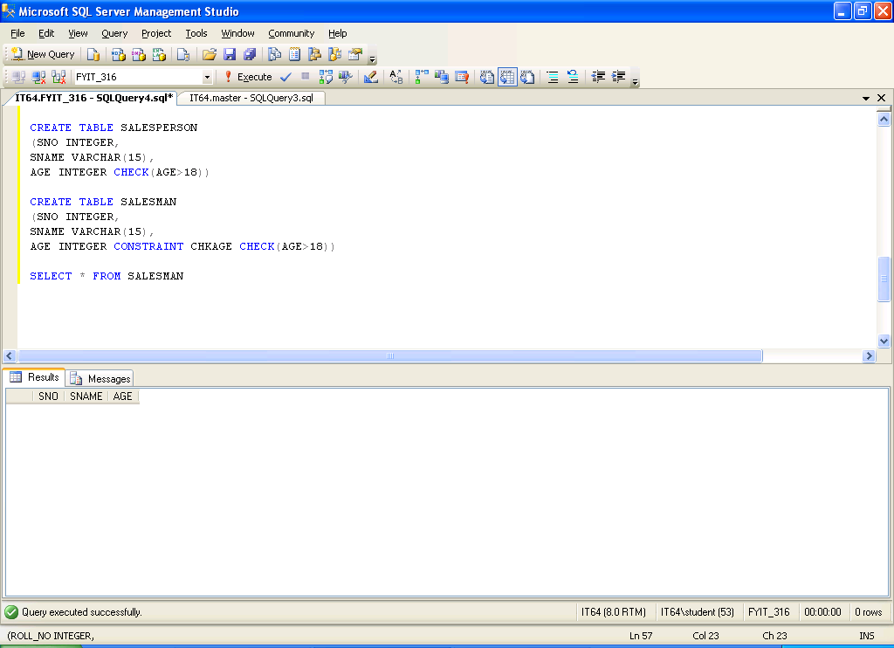

**NOT NULL CONSTRAINTS**

CREATE TABLE PRODUCT1

(PRODUCT_NO INTEGER,

PNAME VARCHAR(10)NOT NULL)

SELECT * FROM PRODUCT1

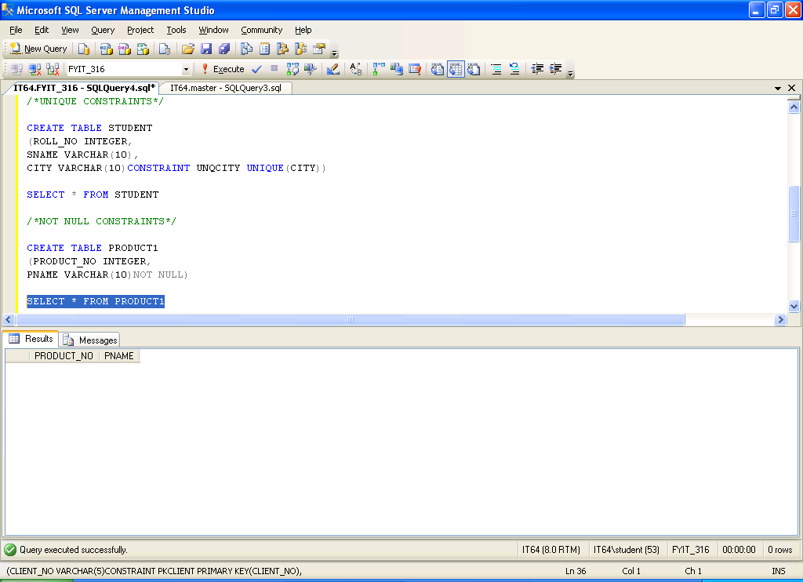

***NOT NULL CONSTRAINTS***

CREATE TABLE PRODUCT1

(PRODUCT_NO INTEGER,

PNAME VARCHAR(10)NOT NULL)

SELECT * FROM PRODUCT1

